**Fewspy installation tutorial**

Fewspy can be installed with pip in any environment with the following Python-packages properly installed: Requests, Aiohttp, Pandas, Geopandas

If you don’t have such an environment, we recommend going through the following steps:

1. Download anaconda via:  [Anaconda](https://www.anaconda.com/)
2. Go to the [environment.yml](https://github.com/d2hydro/fewspy/blob/main/envs/environment.yml) file and click on Raw, see the red line in the figure below. 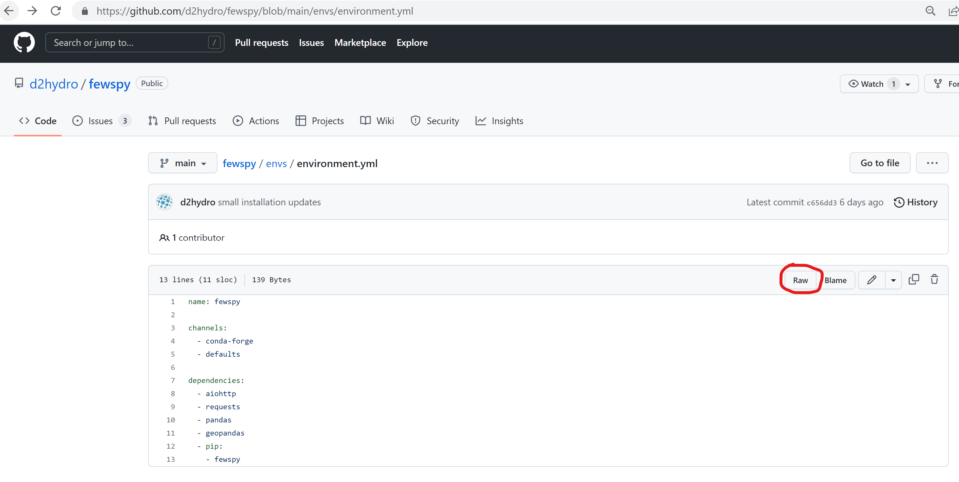
3. Right mouse click and then click on Save as and choose a map on your computer where you want to save this file.

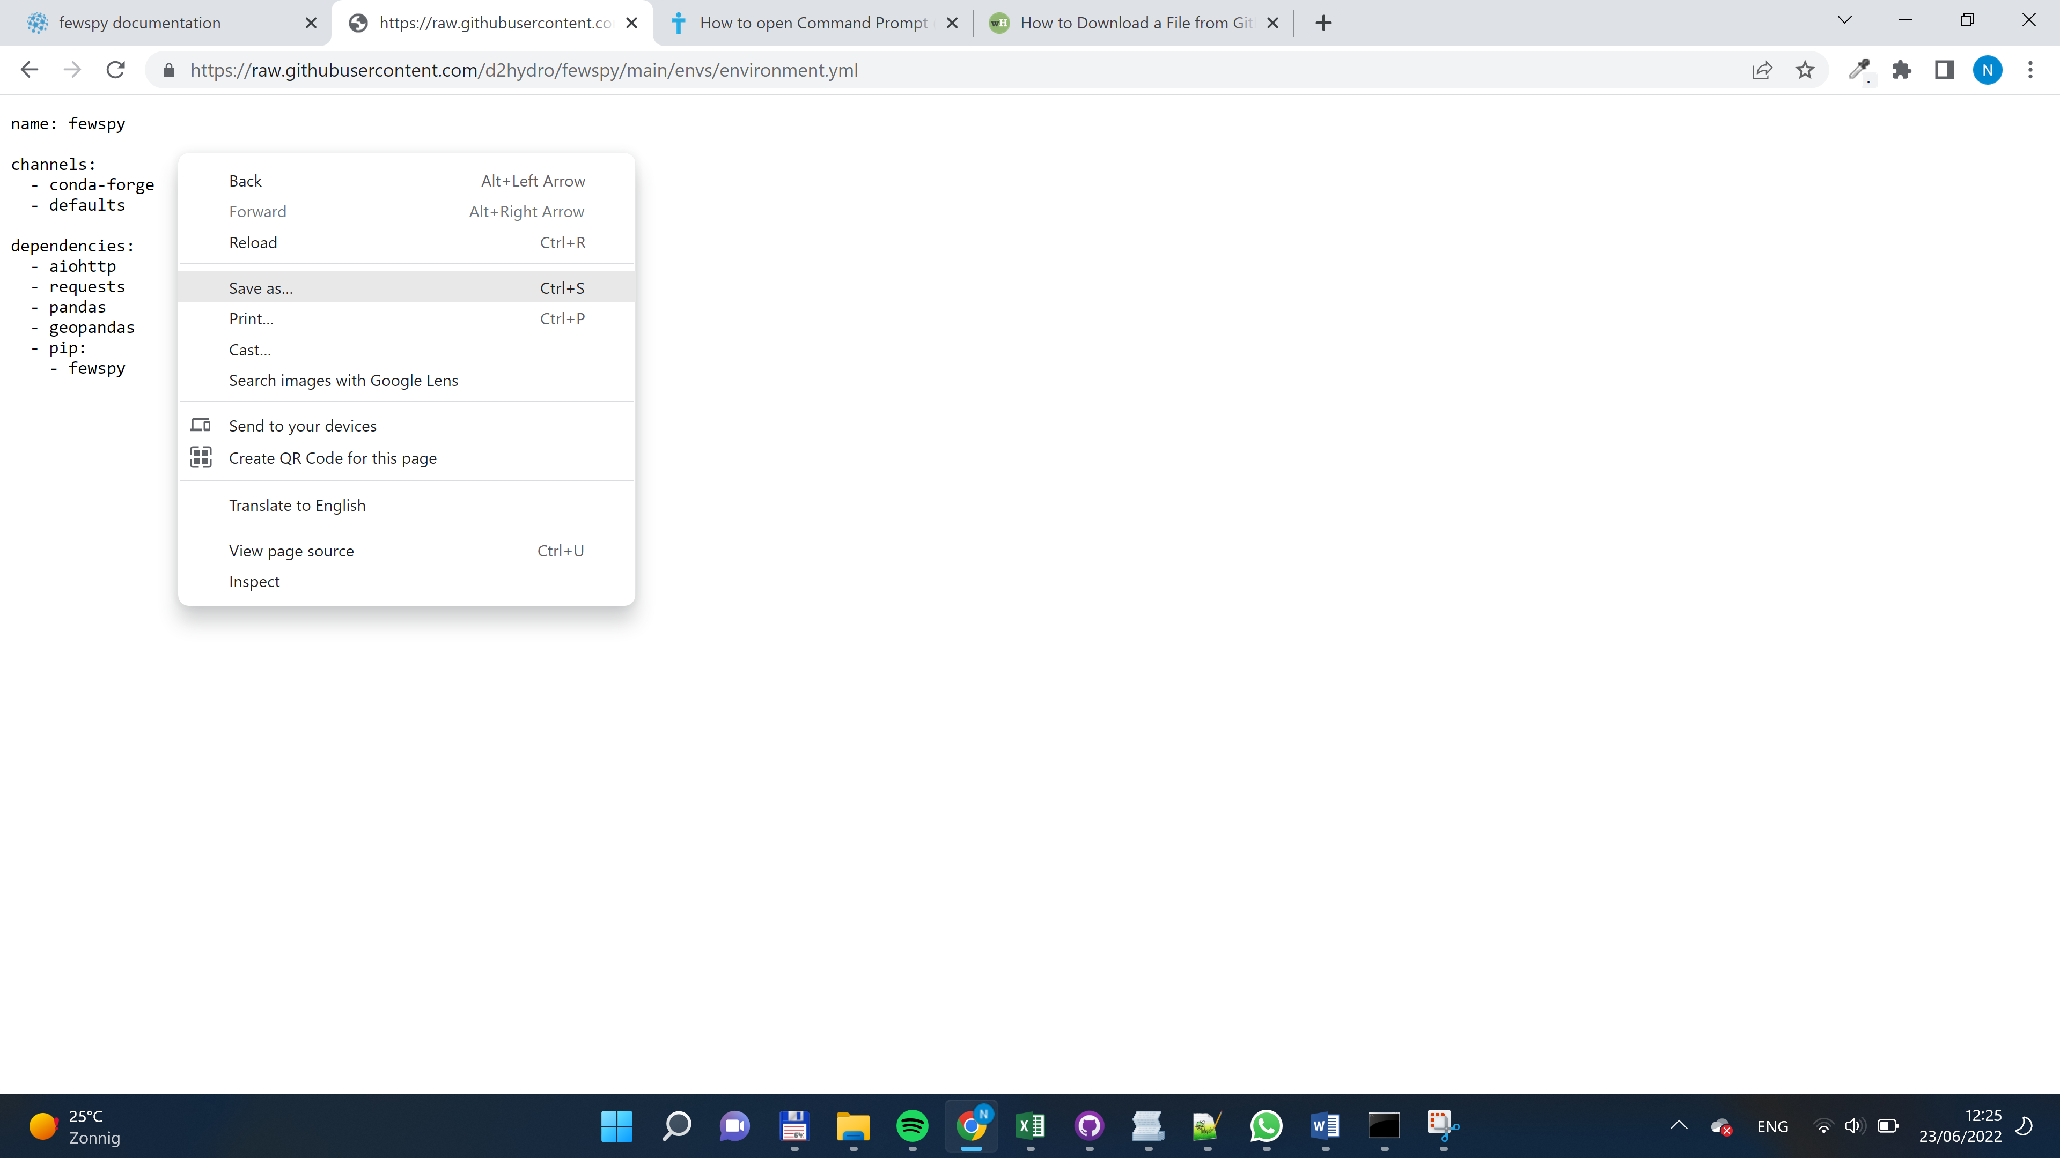

1. Via explorer; Go to the map you saved the environment.yml file in; Type cmd in your address bar and this will open the command prompt in the right folder, see the example below: 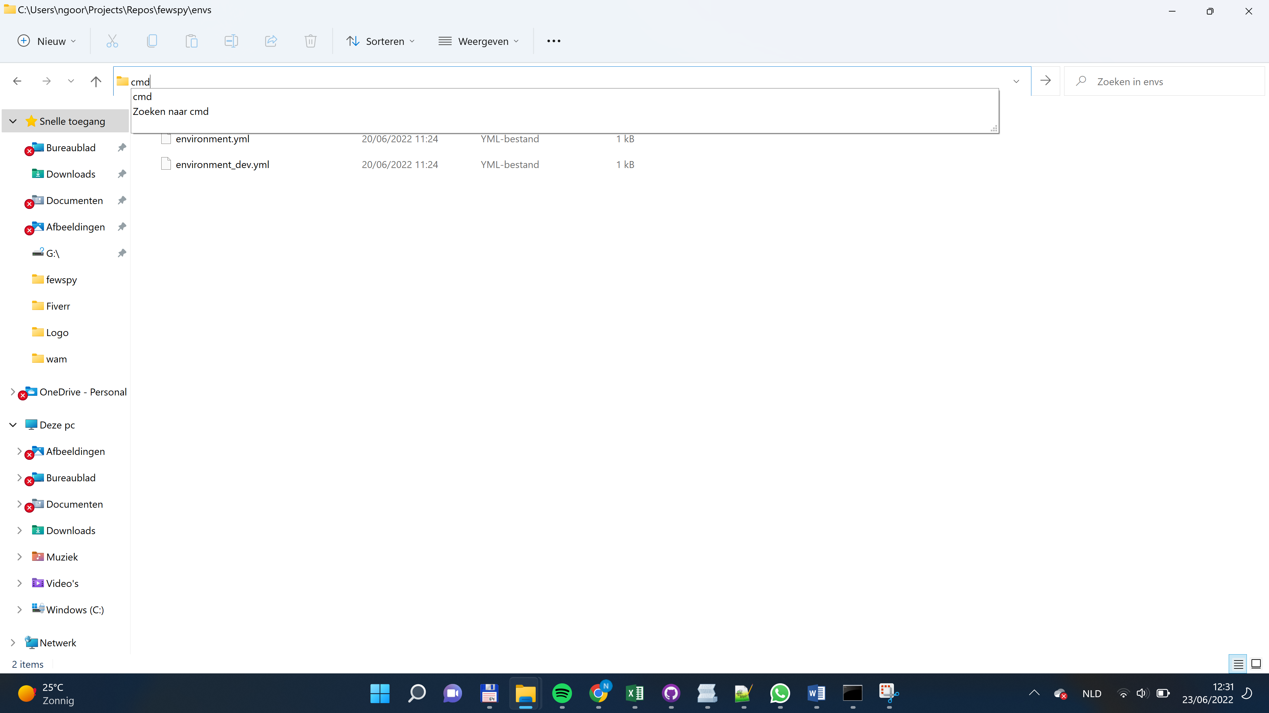

1. Type in your command prompt: conda env create -f environment.yml, see figure below:

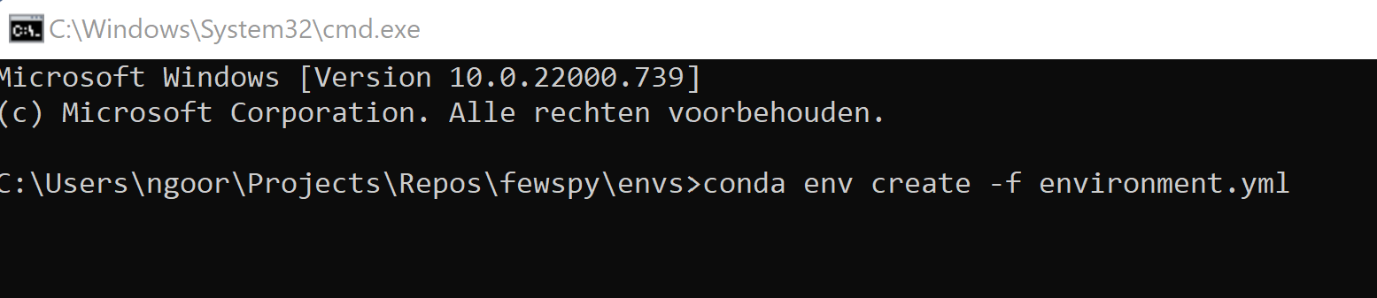

1. If all the modules are properly installed, your environment is created an you are ready to use Fewspy!
2. You can use Fewspy by activating your environment via: conda activate bokeh:

